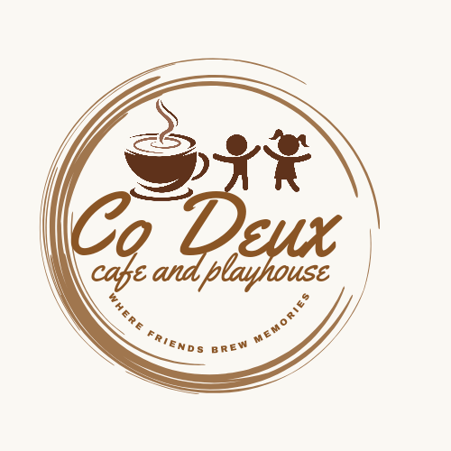

Co Deux Café & Playhouse - Party Venue Hire Booking Form

Personal Details
Full Name: _______________________________________________________
Phone Number: ___________________________________________________
Email: ___________________________________________________________
Child’s Name: _____________________________________________________
Child’s Age: ______________________________________________________
Date of Party: _____________________________________________________
Theme of party:_______________________________________________
Time of Party:
Please tick next to the time slot.
10:00-12:00 |  | 14:00-16:00

Number of Guests:
Children: | Adults:

Party packages:
Please tick the option you have selected.
Basic party package (Non-exclusive use)  Ideal for parents who want a budget friendly simple celebration | Themed party (Exclusive use of mini town) Perfect for families who want a pinterest party without stress | High tea set up (Non-exclusive use)
Weekday: R2000  Weekend: R2500  - Up to 10 ten kids  - 2 hours of play in the mini pretend town and outdoor play area  - Use of the designated party venue area  - White kids table  - White cross back kids chairs  - White table cloth  - Decorated kids tables in the colour scheme of the party- Balloons and bunting. Colour: ________________  - Kids meal with a juice/ cold drink | Weekday: R3500  Weekend: R3950  - Up to 20 kids  - 2 hours of play in the mini pretend town and outdoor pay area  - Use of the party venue and mini town for only your guests  - White kids table  - White cross back kids chairs  - White table cloth  - Themed décor with table settings  - Party packs  - Cupcake for each kid  - Kids meal with juice / cold drink  - Free printable invitation (electronic invite designed for your party) | 10 kids- R2950  20 Kids- R3950  - 2 hours of play in the mini pretend town and outdoor play area  - Use of the designated party venue area  - White kids table  - White cross back kids chairs  - White table cloth  - Decorated kids tables in the colour scheme of the party- Balloons and bunting. Colour: ________________  - Tables decorated in high tea theme

Kids meal for birthday party
Menu: | Number of kids:
Chicken nuggets and chips
Pizza

Themes:
Theme: | Tick the options:
Princess
Mermaid
Barbie
Spa day party
Cupcake decorating
Crafts party
Peppa pig
Superhero
Sports- rugby, soccer
Construction
Dinosaur
Safari/animals
Lego
Paw patrol
Ocean/ shark

Add on options:
Birthday cake (vanilla or chocolate) | R400
Decorate a cupcake | R40
Extra 30 minutes | R350-R500
Party pack | R40-R60

Catering options for adults:

Catering option One: R100 per person
Select 4 Savoury and 4 sweet options from the list below
Catering option Two: R130 per person
Select 6 Savoury and 4 sweet options from the list below

Savoury Options |  | Sweet Options
Spinach and feta quiche |  | Custard tarts
Bacon and cheese quiche |  | Milk tarts
Spring rolls |  | Jam tarts
Samoosas (mince, chicken, cheese and corn, potato) |  | Scones
Mini hamburgers |  | cupcakes
Roti rolls (vegetarian- beans) |  | Mini fruit tarts
Chicken puffs |  | Mini cheesecakes
Savoury pies |  | brownies
Mini crumbed drumsticks
Chicken salad baskets
Mini pulled pork burgers

Beverages:
All beverages are to be purchased from Co Deux café and playhouse.
Additional themed décor
Please contact Renee Moollen from Co Deux café and playhouse to discuss further options.

Vendors:
For further catering options please see the menus attached below.
- Graze and Gather- Charcuterie boards, cones, boats, boxes and tables
You are welcome to bring your own birthday cake or use the vendor below for cakes and biscuits.
- Shays cakery – 076 400 1661

Terms & Conditions
- A non-refundable deposit of 50% is required to secure your booking. Final payment must be made at least 7 days before the event. Any cancellations must be communicated in writing and must be done at least 7 days before the event to receive a refund.
- Date changes are subject to availability and must be confirmed in writing.
- We will allow you to come 1 hour before your party to ensure that all is ready before your guests arrive.
- Once the party is complete all guests have to leave by the stipulated time. Additional time will incur an extra hourly rate.
- Bookings are only confirmed once proof of payment has been received.
- Co Deux Café & Playhouse is not liable for any loss, damage or theft sustained during the event.
- All beverages are to be purchased from the Co Deux café.
- No alcohol allowed to be brought on the premises.
- Co Deux café and playhouse may take photos for social media and marketing purposes. If you prefer not to be featured, please notify us.

By signing below, you acknowledge that you have read, understood and agreed to the above terms and conditions.
Signature: ________________________________ Date:___________

